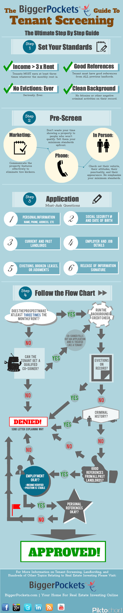

Property:

**Step 1**: *Assemble Your Real Estate Team*

* Find local:
  + Real Estate Agent:

* + - 
    - Have he/she set up a MLS search
  + Contractor & Handyman

* + - 
  + Conventional Lender Specialist

* + - 
  + Property Manager (for future use)

* + - 
  + Lawyer/Attorney
  + Insurance Agent

**Step 2**: *Get your Loan Pre-Approved*

* Shop for loan options. Compare interest rates, down payment, premium mortgage insurance (PMI).
* Contact lender specialist to ask for requirements
  + Need a credit score above 620 for a conventional loan
  + On average the debt-to-income ratio cannot exceed 50%
* Prepare all the required documents
* Submit all the documents and get pre-approved
* Make sure to obtain a pre-approval letter for proof

**Step 3**: *Find Your Property*

* Know your market
  + Types of neighborhood
  + Crimes
  + School ratings
  + Businesses
  + Vacancy rate
  + Unemployment rate
  + Laws on rental housing (tenant & landlord)
  + Typical property price range
  + Typical rent price range
* Analyze deals
  + Source of deals include:
    - MLS through real estate agent
    - Portals
    - Absentee owner list
    - Drive for dollars
* Metrics:
  + Use personal excel template to identify deal
    - 
* Offer up on deals
  + Negotiate on purchase price
  + Possibly offer earnest money to sweeten the deal
* Accept the deal (with):
  + Home inspection contingency
  + Financing contingency
  + Clause that the seller should not be responsible for any costs under $1000

**Step 4**: *Get Your Loan Approved*

* Call lender and submit the property information
* Appraisal

* + 
* Submit more documents
* Loan approved

**Step 5**: *Due Diligence*

* Hire a Lawyer/ Title Company for:
  + Title inspection
  + Document inspection
* Hire a Property Inspector for:
  + Physical Inspection – go to the inspection and make a list of everything you need to fix up and what the seller needs to fix up.
* Other possible inspections:
  + Plumber (Inside Drainpipes)
  + Pest Inspector
  + Asbestos
  + Lead-Based Paint

**Step 6**: *Getting Ready to Close*

* Order insurance from your insurance agent
  + Homeowner’s insurance or rental property insurance
* Setup business checking & savings account
* Obtain a credit card specifically for business
* Prepare all the necessary forms on managing your property
* Prepare bookkeeping
* Understand the local, state and federal Fair Housing Laws in the area
* Final walk through the property
* Plan the rehab if needed (do this while doing physical inspection)
* Double check the documents and sign

**Step 7**: *The Rehab Stage (If doing)*

* Present the rehab plan to the contractors and ask for a bid
* Hire contractor with the best service, qualifications, and project history, and reasonable price
* Create a checklist for the project and give to the contractor (only pay the contractor each time they get something done on the checklist)

**Step 8**: *Find Tenants*

* Advertise your rental property:
  + For rent sign
  + Craigslist
  + Newspapers
  + MLS
  + Portals
  + Flyers
  + Rental App (like Apartmentlist.com, RentCafe.com, RentSpree, Pocketlist)
    - Describe the property or community that attracts a type of person you want, rather than directly describing the type of tenant you want to avoid FH lawsuits
    - Take pictures like you are giving a tour of the house
  + Existing tenants
  + Track the number of inquiries you receive
    - 

**Step 9**: *Screen Your Tenant.*

* Set your Rental Criteria
* Pre-Screen
  + Set up initial phone call for 2 minutes asking if they have any initial questions.
  + Ensure understanding of the Fair Housing Laws
* Provide Application and Tenant Standards to perspective tenants

* + 

* + 
* Send Apartments.com link to obtain a Background and Credit Check
  + Prior Felonies within 7 years
  + Prior Evictions Filed
  + Prior Evictions Carried Out
  + Bankruptcies
  + Judgments
  + Criminal Issues or bad financial History
* Ensure applicants results
  + Check social media
  + Call previous landlords

* + - 
  + Verify employment by calling employer

* + - 
  + Call personal references
* Verify Income & Renting History
* Provide a group showing for all prospective tenants
  + Confirm with tenant that they have the showing the day before

**Step 10**: *Accept Tenant.*

* Lease Agreement

* + 
* Move-In Condition Report
* Security Deposit = 1-month rent payment
* Provide Move in Information
  + Tenant Welcome Letter

* + - 
  + Welcome Packet

* + - 

**Step 11**: *Train Your Tenant or Yourself.*

* How to handle these scenarios:
  + Late Rent
  + Neighbor Conflicts
  + Moving-In Unapproved Pets or People
  + Breaking a Lease
  + Drugs

**Step 12**: *Manage Effectively.*

* Track Expenses and Income (Bookkeeping)
* Setup [www.Apartments.com](http://www.Apartments.com) for automatic monthly rent deductions for tenants
* Create a System of Action when an emergency repair/non-emergency needs to get done.
* Weekly Housekeeping (Common Area & Private Rooms)
  + Test smoke and carbon monoxide detectors
  + Check for leaks and water damage
  + Maintain heating and cooling systems
  + Check caulking and grout in bathrooms
  + Ensure doors and windows are secure
* Schedule House Maintenance Check
* Maximize Income Each Year
* Minimize Expenses
* Formula for fixing it yourself over getting a handyman:
  + Dollar per hour wage ($36 currently) x hours worked < handyman cost