Last updated: 1/29/21

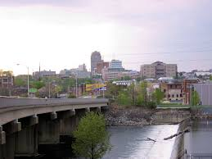

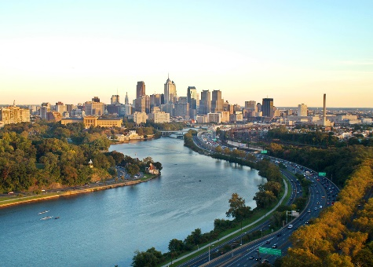

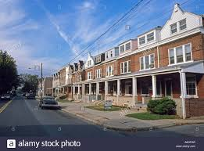

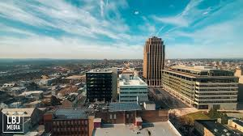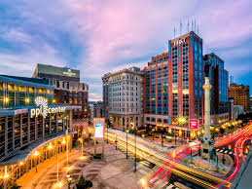

# Welcome!

The following information package was created to aid you in your move to Allentown, PA. This is not a complete list of things to do and see, by any means, but should get you a starting point.

Table of Contents

Welcome! 1

Map of the Area 3

Major Cities within Driving Distance 4

Things to Do/Where to Take Guests 4

Attractions 5

Shopping 8

Gyms 8

Sports & Activities 10

# Map of the Area

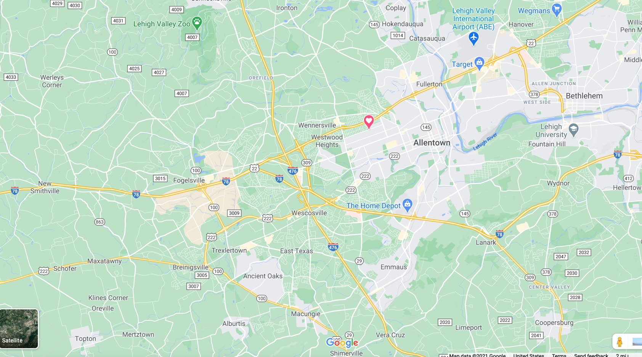

**Major Highways**: US22, 78, 476, 222

# Major Cities within Driving Distance

So you’re moving from a city to Allentown, or you’ve never been to the east coast and want to know how to get your city fix?

Allentown is located near enough that you can visit Philadelphia, New York City, or Washington D.C. for a day or weekend.

**Philadelphia -** About an hour drive, but look out for traffic on I-76. Best way to get there is by driving south on I-476 (which is a toll road).

**NYC -** About a 2-hour drive. There are multiple ways that can get you to New York City.

**Washington D.C. –** About a 3.5-hour drive. To avoid the Philadelphia traffic, try to navigate by Harrisburg and Gettysburg.

# Things to Do/Where to Take Guests

# Dorney Park and Wildwater Kingdom - CCUSA Job Profiles

# Attractions

### **Dorney Park/Wildwater Kingdom:** <https://www.dorneypark.com>

### **Dutch Wonderland:** <https://www.dutchwonderland.com>

### **Lehigh Valley Zoo:** <https://www.lvzoo.org>

### **Pines Dinner Theatre:** <https://www.pinesdinnertheatre.com>

### Dutch Wonderland Family Amusement Park® in Lancaster PA - Kids Love It!

### **Becky’s Drive in:** <https://www.beckysdi.com>

### **Crystal Cave**: <https://crystalcavepa.com/home/>

### **Li'l-Le-Hi Trout Nursery**

### **Jim Thorpe River Adventures**: <https://jtraft.com>

### **Allentown Farmer’s Market:** <https://www.allentownfarmersmarket.com>

### Lehigh Valley Phantoms - Wikipedia

### **Lehigh Valley Phantoms:** <http://www.phantomshockey.com>

* **Allentown/Bethlehem Brew Works:** <http://www.thebrewworks.com/>

Brew Works is a restaurant and brewery which hosts a number of events. A few of these include: comedy nights, intramural sports, trivia night, girls nights, etc.

* 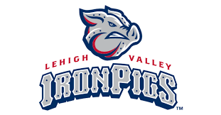**The Crayola Factory:** <https://www.crayolaexperience.com>

### **Hershey Park:** <https://www.hersheypark.com>

### **The Sands Casino:** <https://www.sandscasino.com>

**Lehigh Valley Iron Pigs:** <https://www.milb.com/lehigh-valley>

The Triple-A affiliate of the Philadelphia Phillies.

### **The Banana Factory**: <https://www.bananafactory.org>

Cultural arts and education center in historic Bethlehem. Contains three galleries, 28 resident artists, Fowler Arts and Education Center, GlassWorks – Lehigh Valley’s only hot glass studio, Olympus Digital Imaging Center, and The Gallery Shoppe

* **America On Wheels:** <http://americaonwheels.org>

### **Wineries**

The Lehigh Valley is Pennsylvania’s fastest growing wine region. The Lehigh Valley Wine Trail is made up of nine family-owned wineries. Check out the website for special events and directions. <https://lehighvalleywinetrail.com>

**Festivals, Carnivals, and Fairs**

* **Musikfest:** <https://www.musikfest.org>

The most popular festival in the Lehigh Valley, and is held every summer in Bethlehem.

* **Celtic Classic Festival:** <https://www.celticfest.org>

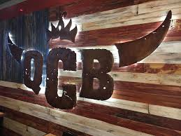

Late-September

* **Bethlehem Harvest Festival**

Mid-October

**Night Life**

* **Queen City BBQ:** <https://www.qcballentown.com>
* 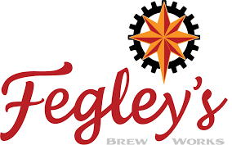**Fegley’sBrew Works:** <https://thebrewworks.com>
* **The Hamilton:** <https://thehamiltonkitchen.com>
* **Liberty Tavern:** <https://www.tavernonliberty.com>
* **Roosevelt’s 21st:** <https://www.21crafthouse.net>
* 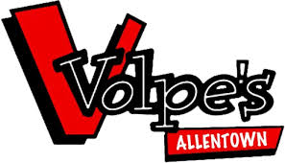**Stahleys:** <https://www.stahleys.com>
* **PJs:** <https://www.pjspub.com/about.php?loc=Allentown>
* **Bru Daddy’s:** <https://www.brudaddysbrewingcompany.com>
* 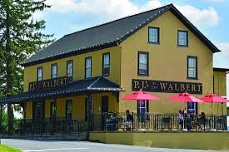**Bell Hall:** <http://www.bellhallallentown.com>
* **Greg’s Saloon**
* **Jack Callahan’s**
* **Volpe’s**: <https://volpessportsbar.com>

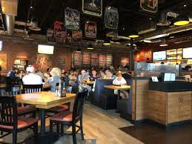**Restaurants**

**Casual Dining**

* Yocco’s Hotdogs (Hamilton Blvd, Allentown)
* Panera Bread (Hamilton Blvd, Allentown)
* Five Guys (Tilghman St, Allentown)
* Red Robin (Tilghman St, Allentown)
* Primo café (Ruppsville Rd, Allentown)
* 3 Men and a Bagel (Hamilton Blvd, Allentown)
* 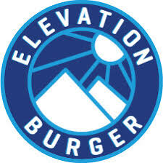Chick-fil-a (Hamilton Blvd, Allentown)
* Cali Burrito (Hamilton Blvd, Allentown)
* Café Santosha (Hamilton Blvd, Allentown)
* Elevation Burger (Tilghman, Allentown)
* Alburtis Tavern (Macungie)
* CoreLife (Krocks Rd, Allentown)
* BJ’s (Krocks Rd, Allentown)
* 1760 (Trexlertown Rd, Allentown)

**Asian**

* 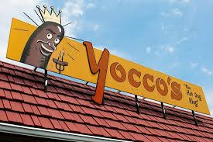Asian Bistro (Hamilton Blvd, Trexlertown)
* New China Moon (Rt 100, Trexlertown)
* Hunan Springs (Hamilton Blvd, Allentown)
* Liu’s house (Tilghman, Allentown, PA)
* Hana (MacArthur, Whitehall, PA)
* Thai Ave (Tilghman, Allentown)
* Bamboo (Hamilton Blvd)

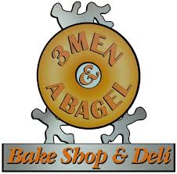**Italian**

* Joe’s Pizza
* Mazzola’s Italian Restaurant (Rt 100, Trexlertown)
* Vince’s Cheese steaks and Pizza
* Italiano Delight Paese Mio
* Mama’s Italian Kitchen
* Anthony’s Coal Fired Pizza

**Lesser-known/Unique to the area**

* The Burgery (Emmaus) – all about making a good burger
* Cali Burrito – Tacos, Burritos, Breakfast Burritos, Fajitas, Quesadillas
* The Foundation/Krocks – Outdoor patio, indoor billiards/shuffleboard, wing night Fegley’s Brew works (2 locations) –Bethlehem, Allentown
* Macungie Pub – historic feel
* Steel City Gyro – (Hamilton Blvd, Trexlertown)
* Lazeez – Mediterranean
* Old School – Sandwiches (Allentown – Off Rt. 100)

# Shopping

### **Lehigh Valley Mall:** <https://www.simon.com/mall/lehigh-valley-mall>

The closest mall for Allentown.

### **The Promenade Shops of Saucon Valley:** <https://www.thepromenadeshopsatsauconvalley.com>

### Has plenty of restaurants and a Rave movie theater. Note this is an outdoor mall.

### **King of Prussia Mall:** <https://www.simon.com/mall/king-of-prussia>

Premiere shopping destination. About an hour to an hour and fifteen-minute drive from Allentown.

### **Philadelphia Premium Outlets:** <https://www.premiumoutlets.com/outlet/philadelphia>

About an hour to hour and a half drive since it is down by Philadelphia.

### **The Crossings Premium Outlets:** <https://www.premiumoutlets.com/outlet/the-crossings>

About an hour north of Allentown area, towards the Poconos.

# Gyms

#### **The Fitness Plaza**

1124 Glenlivet Drive Allentown, PA

### **Golds Gym**

2919 Lehigh St. Allentown, PA

#### **Steel Fitness/Human Performance Center**

250 Cetronia Road Allentown, PA

11 W. 2nd Street Bethlehem, PA

#### **LA Fitness**

1515 Mauch Chunk Road Allentown, PA

#### **Planet Fitness**

1302 Hanover Avenue

Allentown, PA 18109-2096

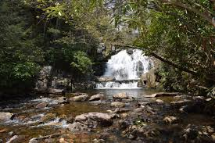**Local Parks**

* Jim Thorpe (Jim Thorpe, PA)
* Cranberry Bog (Tannersville, PA)
* Rickets Glen State Park (Benton, PA)
* Hawk Mountain (Kempton, PA)

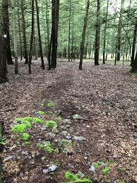

* Lehigh River Trail (Easton PA to Bethlehem PA to Rockport PA)
* Jacobsburgh State Park (Wind Gap, PA)
* Noxamixon State Park (Quakertown, PA)
* Lehigh Gorge State Park (White Haven, PA)
* Hickory Run State Park (White Haven, PA)
* Big Pocono State Park (Tobyhanna, PA)
* Trexler Memorial Park (153-199 Springhouse Road, Allentown PA)

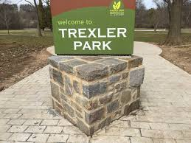

* Little Lehigh Parkway (Allentown, PA)

**Hiking Trails**

### Bake Oven Knob

* Lehigh Gap East
* Lehigh Gap West
* Monocacy Way
* D&L Trail
* Glen Onoko Falls
* Trexler Nature Preserve

# Sports & Activities

* **Lehigh Valley Sport and Social -** <https://heydayathletic.com>
* **Bowling Leagues:**

Jordan Lanes, Emmaus Bowling Center, AMF Parkway Bowling Lanes, Revolutions

### **Lehigh Valley Softball**

Lehigh Valley co-ed softball: [*http://www.lvcoedsoftball.com/*](http://www.lvcoedsoftball.com/)

Easton women’s softball league: [*http://www.leaguelineup.com/welcome.asp?url=ewsl*](http://www.leaguelineup.com/welcome.asp?url=ewsl)

### **Soccer**

Men and Women’s leagues: [*http://www.lvssl.org/*](http://www.lvssl.org/)

* **Rock Climbing:**

North Summit (indoor)

* **Skiing/Snowboarding:**

Bear Creek, Blue Mountain, Jack Frost Big Boulder, Camelback Mountain Resort

### 

### **Golf Courses**

|  |  |  |  |  |
| --- | --- | --- | --- | --- |
| Course Name | Weekend Morning Price | Weekend Afternoon Price | Weekend Twilight Price | Web Site |
| Allentown Municipal  Golf Course | $40 | - | $29 | *allentowngolf.org* |
| Woodbridge Golf Club | $48 | $36 | $24 | *playwoodbridge.com* |
| Center Valley | $80 | $48 | $26 | *centervalleyclubgolf.com* |
| Iron Lakes | $44 | $33 | $27 | *ironlakescountryclub.com* |
| Berkleigh Golf Club | $50 | $35 | $25 | *berkleighcountryclub.com* |
| Bethlehem Municipal | $45 | - | $33 | *bethlehemgc.com* |
| Olde Homestead | $60 | $50 | $30 | *oldehomesteadgolfclub.com* |
| Golden Oaks | $65 | $50 | $35 | *goldenoaksgolfclub.com* |
| Morgan Hill | $69 | - | $54 | *theclubatmorganhill.com* |
| Whitetail Golf Club | $58 | - | $39 | *whitetailgolfclub.com* |
| Southmoore | $55 | $43 | $43 | *southmooregolf.com* |
| Architects Golf Club | $80 | $50 | $40 | *thearchitectsclub.com* |